Design Document
Hot Air

Table of Contents
Design Document 1
1. Introduction 3
1.1 Purpose 3
1.2 Context 3
1.3 Scope 3
2. Problem statement and research questions 4
2.1 Problem statement 4
2.2 Main research question 4
2.3 Sub-questions 4
2.4 Success criteria for the PoC 5
3. Requirements 5
3.1 Functional requirements 5
3.2 non-functional requirements 6
4. Solution comparison 7
4.1 Candidates 7
4.2 Weighted criteria matrix 7
4.3 Choice for the proof of concept 8
5. Architecture design 8
5.1 Architecture overview 8
5.2 Components 9
5.3 Network design 9
5.4 Identity and access 10
5.5 Management, updates and monitoring 11
6. Security design 12
6.1 Threats and measures 12
6.2 Hardening baseline 12
6.3 Privacy (GDPR/AVG) 13
7. Test plan and results 13
7.1 Test cases 13
7.2 Performance and scalability results 14
7.3 Application compatibility results 14
7.4 Conclusions from testing 14
8. Cost-benefit analysis 14
8.1 Assumptions 14
8.2 Total cost of ownership 15
8.3 Non-financial benefits and drawbacks 15
8.4 Conclusion for SQ7 15
9. Risks, limitations and assumptions 15
9.1 Risks of deploying the solution 15
9.2 Limitations of this research 16
9.3 Assumptions 16

Introduction
This section is an introduction to the Hot Air BV project and contains a brief overview of what the purpose of the project is, what is in Scope and what is not.

1.1 Purpose
The purpose of this project is to find out, based on evidence, whether an open-source virtual workplace can realistically replace or supplement a commercial solution such as Microsoft RDS in an organization. This will be done through deep research and implementation back-to-back for comparison of the results.

1.2 Context
Many organizations nowadays run virtual workplaces on commercial products such as Microsoft RDS, Citrix, Omnissa, Horizon or Azure Virtual Desktop. These bring licensing and management costs and dependence on a vendor. An open-source solution might have a higher cost for setting up, but after that the monthly costs of running it come a lot cheaper. Our job is to research if it is worth it to make that initial investment or if companies should stick to vendor solutions.

1.3 Scope
In scope | Out of scope
Research on VDI, remote desktop protocols, thin and fat clients and comparisons of commercial vs open-source solutions | Production deployment or a real migration
The functionality a virtual workplace needs (authentication, remote access, applications, sessions, profiles, security, updates, logging, central management) | Migration of existing users
Designing an architecture for an open-source virtual workplace, including network, identity, storage, management and security | Formal security audits or penetration tests. Basic security tests are in scope.
Proof of concept in a lab environment (Proxmox), including central loging, browser-based desktop access, persistent user profiles across at least two session hosts, automated deployment with Ansible, basic monitoring and central logging | End-user training and organizational change management
Testing with a small amoount of concurrent users on performance, user experience, manageability, security and scalability | More than 10 concurrent users
Cost-benefit analysis comparing the open-source setup with one commercial baseline, based on public pricing and stated assumptions
Advisory report: risks, feasibility, limitations and next steps

2. Problem statement and research questions
This section contains the main research question for this project followed by the sub-questions, which support it.

2.1 Problem statement
Commercial virtual workplace solutions involve significant licensing and management costs. It is unknown whether an open-source virtual workplace can be sufficiently practical, secure, manageable and cost-effective for use within a small organization. This requires extensive research to an open-source solution when compared to the paid vendors.

2.2 Main research question
To what extent can an open-source virtual workplace be a practical, secure, manageable and cost-effective alternative to a commercial solution for a small size organization?

2.3 Sub-questions
# | Sub-question | Method | Criteria
SQ1 | What functionality does a commercial virtual workplace solution provide, and which requirements follow from it for an open-source alternative? | Analysis of one commercial baseline (e.g. Microsoft RDS), literature, expert interview | Baseline for all
SQ2 | Which open-source components can meet these requirements, and how do they compare with commercial solutions? | Desk research, weighted comparison matrix | Practical
SQ3 | What architecture is suitable for an open-source virtual workplace? | Design, based on SQ1 and SQ2 | Practical, secure
SQ4 | How does the proof of concept perform in terms of user experience, application compatibility and scalability with multiple concurrent users? | Load tests, application tests, user test with SUS questionnaire | Practical
SQ5 | How manageable and secure is the solution, and which risks remain? | Management tasks timed in PoC, threat analysis, basic security tests | Manageable, secure
SQ6 | How do the total costs and management overhead compare with a commercial solution? | Cost-benefit analysis with stated assumptions | Cost-effective

2.4 Success criteria for the PoC
- A user can log in with central credentials and get a desktop via browser
- User profile persists across sessions and session hosts
- 10 concurrent users with acceptable latency
- Two types of desktops can be deployed (fat and thin)
- A user from certain department has limited access to tools for other departments

3. Requirements
The requirements bellow are determined from the functionality of the commercial baseline (Microsoft RDS), the assignment details and client preferences.

3.1 Functional requirements
ID | Requirement | Priority
FR-01 | Users authenticate with central credentials (single identity) | Must
FR-02 | Users access a full desktop remotely from a browser or a client (thin or thick) | Must
FR-03 | Standard office applications are available in the session | Must
FR-04 | Solution follows Zero Trust Principles | Must
FR-05 | User profiles and home directories persist across session hosts | Must
FR-06 | Administrators can manage users, groups and access centrally | Must
FR-07 | Updates and software are deployed centrally | Must
FR-08 | Session and access activity is logged centrally | Should
FR-09 | RBAC between different user groups | Should
FR-10 | Multi-factor authentication is supported | Should
FR-11 | Clipboard, printing and file transfer can be enabled per policy | Could
FR-12 | Windows-only applications are available (e.g. via Wine or a Windows host) | Could

3.2 non-functional requirements
ID | Category | Requirement | Measurable target (to be discussed)
NFR-01 | Performance | Responsive desktop for office work | Input latency < [X] ms; login < [X] s
NFR-02 | Scalability | Supports concurrent users per host | ≥ [X] users per [vCPU/RAM]
NFR-03 | Availability | Service is available during working hours | [X]% uptime; no single point of failure for [component]
NFR-04 | Security | Traffic is encrypted end to end | TLS 1.2+ on all external connections
NFR-05 | Manageability | New session host deployed automatically | < [X] min via Ansible
NFR-06 | Usability | Comparable to current Windows workplace | SUS score ≥ [X]
NFR-07 | Compliance | Meets GDPR/AVG and organisational policy | [policy reference]
NFR-08 | Cost | Total cost of ownership lower than current solution | ≤ [EUR] per user per year

4. Solution comparison
This section compares commercial and open source options on the same criteria, weighted by what matters most for a small organisation whose users mainly work in Windows. Scores run from 1 (poor) to 5 (excellent); the weighted total is the sum of weight × score.

4.1 Candidates
Option | Type | Description
A. Microsoft RDS | Commercial (baseline) | Windows Server with the RD Gateway, Web Access, Connection Broker and Session Host roles, Active Directory and FSLogix profiles
B. Azure Virtual Desktop | Commercial (cloud) | Microsoft-managed control plane in Azure; session hosts run as Azure VMs, paid per use
C. Hybrid open source | Open source infrastructure + Windows hosts | Guacamole, Nginx, Authentik, Samba AD, Samba file server, Ansible and Prometheus/Grafana/Loki around Windows Server session hosts, plus a small Linux pool
D. Fully open source | Open source | The same infrastructure, with Linux desktops only (XFCE + XRDP) and no Windows

4.2 Weighted criteria matrix
Criterion | Weight | A. RDS | B. AVD | C. Hybrid | D. Fully open source
Functionality coverage (FR-01 to FR-12) | 20% | 5 | 5 | 4 | 3
Performance / user experience | 15% | 4 | 4 | 4 | 3
Security features (MFA, encryption, audit) | 15% | 4 | 5 | 4 | 4
Manageability and automation | 15% | 4 | 5 | 3 | 3
Scalability | 5% | 4 | 5 | 3 | 3
Application compatibility (incl. Windows apps) | 15% | 5 | 5 | 5 | 2
Licensing cost | 10% | 2 | 1 | 3 | 5
Community / vendor support and maturity | 5% | 5 | 5 | 3 | 3
Weighted total (out of 5) | 100% | 4.20 | 4.45 | 3.80 | 3.20

4.3 Choice for the proof of concept
The stack chosen for the Proof of Concept is Option C. It manages to fulfill all of the business requirements in the project as well as requirements set by the client. During a meeting with the client, we agreed that there would be Windows desktops available so that crosses off option D, which was the second most likely to be chosen.

5. Architecture design

This section describes the architecture of the hybrid solution chosen in 4.3. Every component traces back to one or more requirements from section 3.

5.1 Architecture overview
The architecture of the solution contains a pfSense router that spreads into 3 subnets: Web Server (Where the applications the staff will be accessing are), a monitoring subnet (To ensure everything is monitored and safe) and a User’s subnet (Containing the server hosting the VMs, the ACDC and a session hoster, which could potentially also be hosted on the main AD/DC hosting server) The router itself will contain the NAT gateway, the Firewall and the VPN.

5.2 Components
Component | Chosen product | Role | Requirements covered
Access gateway | Apache Guacamole | Browser-based entry point, protocol translation | FR-02
Reverse proxy / TLS | Nginx | TLS termination, load balancing | NFR-04
Session hosts | Linux + CFCE + XRDP | Mainly Windows Server (Remote Desktop Session Host role), plus a small Linux pool | FR-02, FR-03
Identity management | Samba AD | Users, groups, Kerberos, HBAC, MFA | FR-01, FR-06, FR-09
Profile / file storage | Samba File Storage | Home directories, roaming profiles | FR-05
Configuration management | Ansible with playbook | Provisioning, updates, app deployment | FR-07, NFR-05
Monitoring and logging | Prometheus + Grafana + Loki + windows_exporter | Metrics, central logs, alerts | FR-08

5.3 Network design
[Network segments/VLANs (DMZ, management, session, storage), IP plan, firewall rules, ports per protocol, DNS. Add a table of flows: source → destination, port, protocol, purpose.]
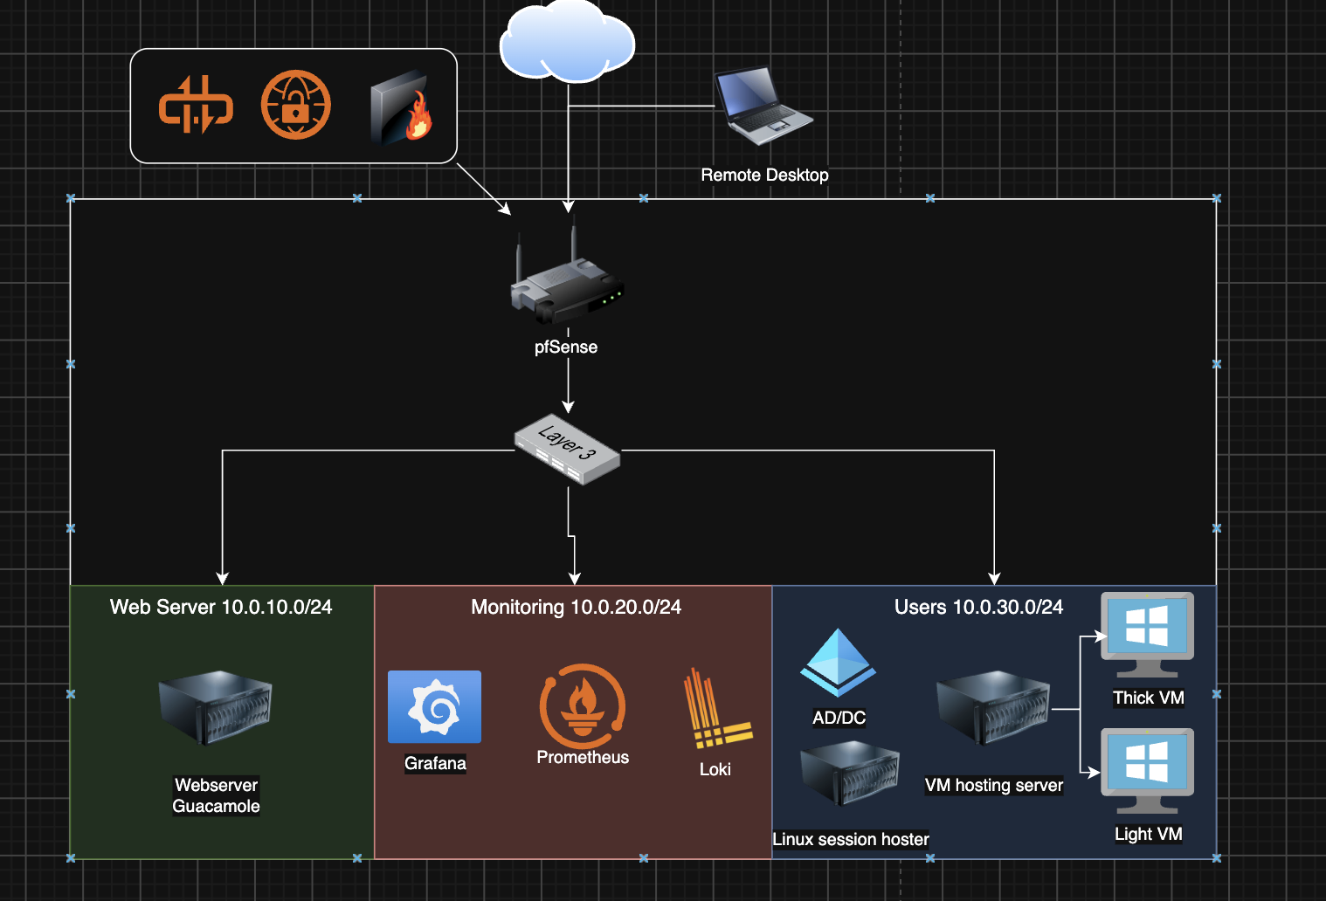

5.4 Identity and access
This diagram shows the flow of the identity of a user and their access. It starts with the user trying to open the workspace, where since they don’t have a token, the user gets redirected to Authentik to log in with their credentials. After they submit these credentials are checked towards the Samba AD and if successful the user gets a token and their desktop instance gets launched. After the instance has been powered on, they can see it’s screen and access it in the browser. When logged in each user can only access resource that their respective group needs for work.
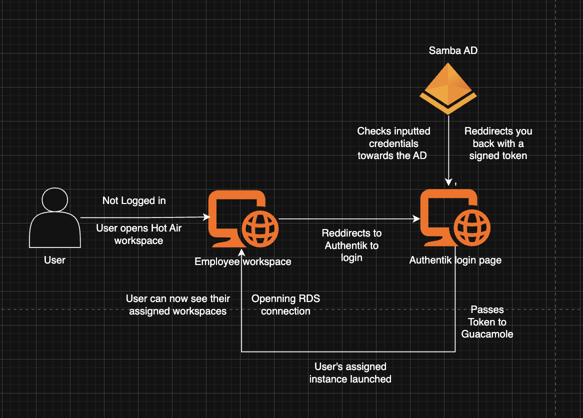

5.5 Management, updates and monitoring
Updates:
- All desktop instances are updated and maintained through an ansible playbook running on schedule.
Monitoring:
- node_exporter and windows_exporter on every host, plus a check on the Guacamole login page. Grafana dashboards show CPU, RAM, disk, sessions and login activity.
Alerts:
- CPU above 85% for 10 minutes, RAM above 90%, disk above 80%, a host or the login page unreachable, a spike in failed logins.
Logs:
- Windows event logs, Linux system logs and Guacamole/Authentik logs are shipped to Loki with Grafana Alloy and kept for 90 days.
Firewall Logs:
- PfSense can directly send the firewall logs to the Grafana instance

6. Security design
Guidance: identify threats per component and the measure that addresses each. Reference a framework where useful (e.g. CIS Benchmarks, BIO, ISO 27001 controls).
In this section we look over common threats that can occur at any point in time, with likelihood of occurrence and impact level of that threat, as well as example measures that can be taken to lower the chance of it happening. GDPR/AVG is also a key aspect of security as it is the golden standard that companies must follow in the EU to increase the safety of their users and decrease exposure of personal info to 3rd party users and bad actors.

6.1 Threats and measures
ID | Threat | Component | Likelihood | Impact | Measure
T-01 | Credential theft / brute force on the gateway | Gateway | Medium | Medium | [MFA, rate limiting, fail2ban]
T-02 | DNS Poisoning | Network | Medium | High | [TLS, no plain VNC/RDP exposed]
T-03 | Vertical Privilege Escalation | Host | Low | High | [file permissions, SELinux/AppArmor, home quotas]
T-04 | Data exfiltration via clipboard, drive or print redirection | Gateway / host | Low | High | [policy per group]
T-05 | Outdated OS/App version | All | High | High | [Ansible patch cycle, unattended-upgrades]

6.2 Hardening baseline
- OS hardening baseline applied to session hosts
- Only gateway exposed; session hosts in internal segment
- Central logging of logins, sessions and admin actions
- Backups of IdM and profile storage tested

6.3 Privacy (GDPR/AVG)
We will process personal data such as emails, usernames, personal names and phone numbers, which will be stored on our database servers. We will use Authentik for our IAM manager, as it offers more lightweight options and is a better fit for small-to-medium industrial solutions. (Alternative is Keycloak as the industry standard, but is more complex and heavyweight)

The sections bellow are to still be discussed and once the client has agreed on a specific architectural design they will be filled out!!!!

7. Test plan and results
Guidance: every test traces to a requirement. Record the method, the target and the measured result, so conclusions rest on evidence. Detailed logs go in Appendix B.

7.1 Test cases
Test ID | Area | Requirement | Method / tool | Target | Result | Pass/Fail
TC-01 | Functionality | FR-01 | Log in with IdM account via browser | Desktop shown | [ ] | [ ]
TC-02 | Functionality | FR-05 | Log in on sh01, change profile, log in on sh02 | Profile identical | [ ] | [ ]
TC-03 | Performance | NFR-01 | Measure login time and input latency | < [X] s / < [X] ms | [ ] | [ ]
TC-04 | Scalability | NFR-02 | Simulate 1, 5, 10, 20 users (e.g. scripted sessions); record CPU, RAM, network | ≥ [X] users per host | [ ] | [ ]
TC-05 | User experience | NFR-06 | Test users perform standard tasks; SUS questionnaire | SUS ≥ [X] | [ ] | [ ]
TC-06 | Manageability | NFR-05 | Deploy new session host with Ansible; time it | < [X] min | [ ] | [ ]
TC-07 | Manageability | FR-07 | Roll out an update to all hosts | No manual steps | [ ] | [ ]
TC-08 | Security | T-01 | Brute-force attempt on gateway | Blocked after [X] attempts | [ ] | [ ]
TC-09 | Security | T-03 | User attempts to read another user's home | Denied | [ ] | [ ]
TC-10 | Applications | FR-03 | Run each application in 6.6 | Usable | [ ] | [ ]
TC-xx | [area] | [ID] | [method] | [target] | [ ] | [ ]

7.2 Performance and scalability results
[Chart of resource use (CPU, RAM, bandwidth) and latency against number of concurrent users. State the point where the experience degrades.]

7.3 Application compatibility results
Application | Works | Issues found | Workaround
[ ] | [Yes / Partly / No] | [ ] | [ ]

7.4 Conclusions from testing
[Answer SQ4–SQ6 in a few sentences, with the key numbers.]

8. Cost-benefit analysis
Guidance: compare total cost of ownership over a fixed period (e.g. 3 or 5 years) for a fixed number of users. State every assumption and its source; open source is not free once management effort is counted.

8.1 Assumptions
- Number of users: [ ] (concurrent: [ ])
- Period: [3 / 5] years
- Hourly rate for IT staff: EUR [ ]
- [other assumptions, e.g. existing hypervisor capacity reused]

8.2 Total cost of ownership
Cost item (EUR, over [N] years) | Commercial: [name] | Open source: [stack] | Source / assumption
Software licences (per user / per device / CAL) | [ ] | [0 or support subscription] | [ ]
Support contracts | [ ] | [ ] | [ ]
Server and storage infrastructure | [ ] | [ ] | [ ]
Endpoints (thin clients) | [ ] | [ ] | [ ]
Implementation effort (hours × rate) | [ ] | [ ] | [ ]
Management overhead per year (hours × rate) | [ ] | [ ] | [ ]
Training and knowledge building | [ ] | [ ] | [ ]
Total | [ ] | [ ]
Per user per year | [ ] | [ ]

8.3 Non-financial benefits and drawbacks
Aspect | Commercial | Open source
Vendor lock-in / sovereignty | [ ] | [ ]
Required in-house expertise | [ ] | [ ]
Support and accountability | [ ] | [ ]
Flexibility / customisation | [ ] | [ ]

8.4 Conclusion for SQ7
[Break-even point and which option is cheaper under which conditions.]

9. Risks, limitations and assumptions

9.1 Risks of deploying the solution
ID | Risk | Likelihood | Impact | Mitigation | Owner
R-01 | [e.g. Key applications (Teams, Windows-only software) not usable] | [L/M/H] | [L/M/H] | [Hybrid model with Windows host for those apps] | [ ]
R-02 | [e.g. Insufficient Linux expertise in IT operations] | [ ] | [ ] | [Training, documentation, support contract] | [ ]
R-03 | [e.g. Users resist a non-Windows desktop] | [ ] | [ ] | [Pilot group, familiar desktop layout] | [ ]
R-04 | [e.g. Open source component loses maintenance] | [ ] | [ ] | [Choose components with active community or commercial backing] | [ ]
R-xx | [risk]

9.2 Limitations of this research
- [e.g. Load tests simulated, not real users]
- [e.g. PoC scale: N users on lab hardware, not production scale]
- [limitation]

9.3 Assumptions
- [assumption]

